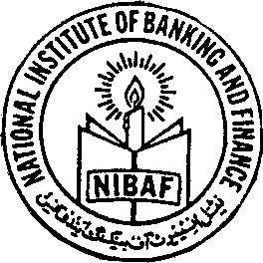 | NATIONAL INSTITUTE OF BANKING AND FINANCE (NIBAF) STATE BANK OF PAKISTAN  ISLAMABAD

Nomination Form

Program Name: Certification in AAOIFI Sharia’as Standards (CASS)
Date:

Venue:

Name of Nominee: (in block letters)  MR/MS/MRS | Male /Female:
Date of Birth:
Name of the Bank / Institution:
Designation | No. of years with the Bank::
Full Address (Office): | Address for Delivery of Certificate
Telephone # (Off.) | Mobile #
E-mail Address: | CNIC #:
Educational Qualification: | Professional Qualification

Course participation fee is Rs.60,000 Plus Sales Tax payable to NIBAF, Islamabad through PO/DD/cheque
(Note: Course fee covers costs related to training delivery, training/reading material, handouts, stationery, during session lunch/refreshments, testing/evaluation & certification etc. It does not include expenses on stay and travelling etc.)

Signature of Nominating authority with stamp………………………….
Date ……………………..

For Queries and Registration

Mr. Ahmed Waseem  Sr. Joint Director  National Institute of Banking & Finance  Islamabad  Phone #:+92-51-9269850-58 Ext:3544  Mobile #:+92-333-212 73 03  Email: Ahmed.Waseem@sbp.org.pk | Mr. Manzoor Ahmad  Joint Director  National Institute of Banking & Finance  Islamabad  Phone #:+92-51-9269850-58 Ext:3544  Mobile #:+92-333-911 65 82  Email: Manzoor.Ahmad@sbp.org.pk

